Car Colour Sales & Customer Preference ETL Project (Excel + MySQL + Python + Power BI)
__________________________________________________________________________________

ETL Project Description
This project centres around designing a decision-support system that helps a car manufacturer determine the most successful colour combination for an upcoming dual-shade vehicle launch. Instead of relying only on past sales, the project integrates two independent data streams: actual sales performance and live customer preferences from showroom visitors. Historical data reflects real market behaviour, while customer feedback captures current trends and future interest. Both datasets are processed through an ETL workflow that standardizes inconsistent entries, identifies hidden patterns, and merges insights from two different perspectives. The final analytical model in Power BI presents a unified view of which colour combinations resonate most with customers today, compared to what has performed well previously. This dual-layered approach ensures that the company makes a product launch decision supported by both factual sales data and real-time customer sentiment—making the solution practical, predictive, and market-aligned.

2.1 Introduction
This project presents an end-to-end ETL pipeline designed for a car manufacturing company evaluating market demand for a new fusion-colour automobile model. The workflow begins with extracting structured historical sales data from Excel and unstructured customer preference data via a Python-based input system. The transformation phase utilizes MySQL to clean, validate, and categorize trends in colour popularity. Finally, the cleansed data is loaded into Power BI, where dynamic dashboards illustrate customer behaviour, sales patterns, and recommended colour combinations for the product launch. The project demonstrates data engineering, analysis, and visualization skills through a practical, industry-relevant problem.
To execute the ETL process for this project, the following tools and technologies were used:
1. Microsoft Excel – Data Extraction
Excel was used as the primary source for collecting and storing historical car sales data.
It provided structured datasets containing model details, colour combinations, and sales figures.
Basic formulas and formatting were also used to clean and prepare the data before transformation.
2. MySQL – Data Transformation
MySQL served as the main tool for transforming and preparing the extracted data.
Tasks performed include:
- Importing sales and customer datasets
- Cleaning inconsistent entries
- Validating colour categories
- Executing conditional queries to identify high, moderate, and low-demand colours
- Preparing transformed datasets for visualization
MySQL ensured accuracy, structure, and reliability of the processed data.
3. Python – Customer Preference Data Collection
Python was used to build an interactive console application to capture real-time customer feedback.
It allowed users to select their preferred colour combinations during showroom visits.
Key functionalities include:
- Input collection from customers
- Flag-based validation
- Counting and categorizing preferences
- Preparing customer feedback data for MySQL
Python acted as a secondary extraction tool for real-time data.
4. Power BI – Data Loading and Visualization
Power BI was used to load both transformed datasets (sales data and customer feedback).
Dynamic dashboards and charts were created to visually compare:
- Historical colour popularity
- Customer current preferences
- High vs. low demand patterns
- Final recommended colour combination for the new model
Power BI provided clear, interactive, and decision-oriented visuals.
Extract phase
The extract phase involved gathering data from two primary sources.
First, historical sales records were extracted from Excel sheets containing model details, colour variants, and sales performance over time. This dataset provided a comprehensive view of past customer behaviour.
Second, a Python-based input system was used to extract real-time customer preferences directly from showroom visitors. This live data captured current market interest and potential future demand. Together, these datasets formed the foundation for the transformation stage.
Transform phase
In the transform phase, the extracted data was cleaned and organized to make it suitable for analysis. Using MySQL, unnecessary values were removed, colour names were corrected, and the data was arranged in a proper format. The sales data was analysed to identify which colours had high, moderate, or low sales. Similarly, customer feedback collected through Python was cleaned and grouped based on preferred colour types. This prepared data was then ready to be loaded for visualization.
Load phase
During the load phase, the transformed datasets from MySQL were imported into Power BI to build interactive visual reports. Both historical sales data and customer feedback data were loaded into Power BI’s data model, where relationships were created for combined analysis. Various visualizations such as bar charts, column charts, and comparative dashboards were designed to highlight colour popularity trends, sales distribution, and customer preferences. The final dashboard served as a decision-support tool, providing clear insights for selecting the ideal colour combination for the new car launch.

2.2 extract phase
2.2.1 How Excel works here extraction phase
Excel was used to extract the initial sales data required for the project. The car sales records, including model names, colour combinations, and the number of units sold, were stored in an Excel sheet. This file served as the main source of raw data, which was later imported into MySQL for further processing.
In this project, a new column named sales_range was created to categorize the sales performance based on the number of units sold. The values in this column were assigned labels such as "Highest", "Moderate", and "Lowest" depending on the sales volume for each colour combination. After categorizing the data, conditional formatting was applied to the sales_range column to visually differentiate each category.
- Highest sales values were highlighted with a specific colour to represent strong performance.
- Moderate sales values were assigned a neutral colour to show average performance.
- Lowest sales values were marked with a separate colour to indicate weaker sales trends.
This visual formatting made the table easier to read and helped quickly identify how each car colour combination performed. It supported faster decision-making and improved the clarity of analysis when interpreting sales.
In the sales_range column, conditional logic was applied to categorize the sales performance of each car colour. The following nested IF formula was used in Excel:
2.2.2 Excel Formula Used
=IF([SELLED_NO] >= 65, "HIGHEST",
IF([SELLED_NO] < 45, "LOWEST",
IF([SELLED_NO] < 65, "MODERATE")))
Logic Behind the Formula
The formula assigns a category based on the number of units sold:
- If the sales value is greater than or equal to 65, it is classified as “HIGHEST”.
- If the sales value is less than 45, it is classified as “LOWEST”.
- If the sales value is between 45 and 64, it is classified as “MODERATE”.
This formula helped categorize each colour combination according to sales performance.
The result was later enhanced using Conditional Formatting in Excel to visually highlight each category with different colours, making the analysis clearer and more readable.

PRODUCT_ID | CAR_TYPE | PRODUCT_COLOUR | PRICE | SALES_NO | SALES_RANGE
10001 | CONVERTIBLE CAR | WHITE | 2500000 | 20 | LOWEST
10001 | CONVERTIBLE CAR | YELLOW | 2700000 | 70 | HIGHEST
10001 | CONVERTIBLE CAR | GREEN | 2700000 | 80 | HIGHEST
10001 | CONVERTIBLE CAR | SILVER | 2700000 | 35 | LOWEST
10001 | CONVERTIBLE CAR | BLUE | 2800000 | 29 | LOWEST
10002 | ELECTRIC CAR | WHITE | 500000 | 36 | LOWEST
10002 | ELECTRIC CAR | BLUE | 500000 | 56 | MODERATE
10003 | HATCHBACK CAR | RED | 1500000 | 100 | HIGHEST
10003 | HATCHBACK CAR | WHITE | 1000000 | 30 | LOWEST
10003 | HATCHBACK CAR | BLUE | 1500000 | 29 | LOWEST
10004 | JEEP | BLACK | 2000000 | 93 | HIGHEST
10004 | JEEP | BROWN | 2000000 | 75 | HIGHEST
10004 | JEEP | RED | 1800000 | 70 | HIGHEST
10005 | LEMOUSINE | BLACK | 9200000 | 89 | HIGHEST
10005 | LEMOUSINE | SILVER | 8000000 | 55 | MODERATE
10005 | LEMOUSINE | WHITE | 9800000 | 26 | LOWEST
10006 | PICKUPTRUCK | BROWN | 780000 | 75 | HIGHEST
10006 | PICKUPTRUCK | WHITE | 800000 | 60 | MODERATE
10007 | CARAVAN | WHITE | 1800000 | 40 | LOWEST
10007 | CARAVAN | MAROON | 1800000 | 59 | MODERATE
10007 | CARAVAN | BLACK | 6000000 | 70 | HIGHEST
10008 | SEDAN CAR | BLUE | 1500000 | 59 | MODERATE
10008 | SEDAN CAR | SLIVER | 1500000 | 66 | HIGHEST
10008 | SEDAN CAR | GREEN | 4000000 | 60 | MODERATE
10009 SELF_DRIVING CAR |  | TURQUOISE | 2500000 | 45 | MODERATE
10009 SELF_DRIVING CAR |  | GREEN | 2500000 | 55 | MODERATE
10009 SELF_DRIVING CAR |  | RUBY RED | 1000000 | 81 | HIGHEST
10010 SPORTS CAR |  | RED | 6000000 | 93 | HIGHEST
10010 SPORTS CAR |  | BLACK | 6000000 | 78 | HIGHEST
10010 SPORTS CAR |  | YELLOW | 2000000 | 76 | HIGHEST
10011 SUV CAR |  | SILVER | 4000000 | 45 | MODERATE
10011 SUV CAR |  | TURQUOISE | 4000000 | 58 | MODERATE
10011 SUV CAR |  | GREEN | 1800000 | 52 | MODERATE
Excel spread sheet report used to extract data

2.3 Transform phase
2.3.1 Let’s looks how the mysql works in transforming data
To begin the transformation phase, the cleaned Excel file containing car sales information was imported into MySQL using the Table Data Import Wizard. This tool makes it simple to load structured data from external files into a MySQL table.
Below are the steps I followed, along with screenshots:
1. Opening the Import Wizard
I opened MySQL Workbench and navigated to:
Server → Data Import → Table Data Import Wizard
This option allows importing Excel/CSV files directly into a selected database.

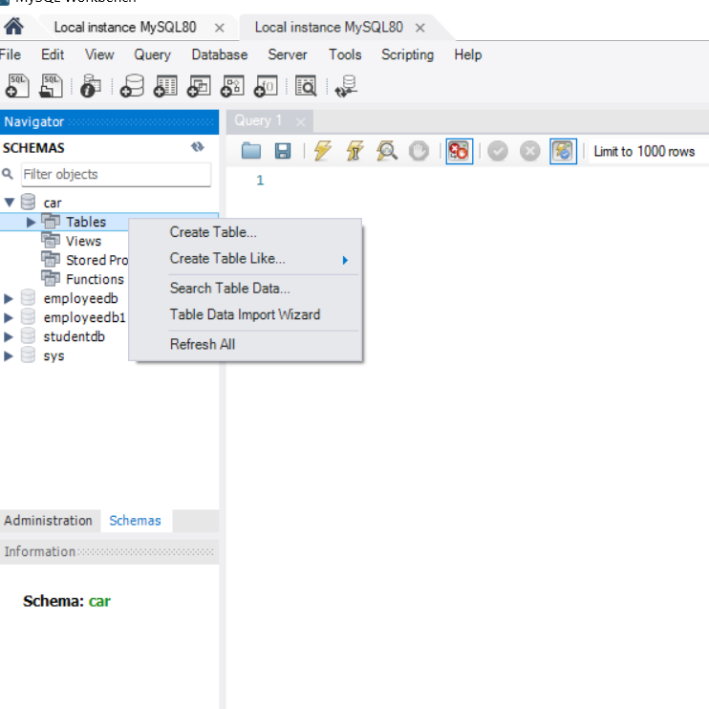

2. Selecting the Excel File
In the wizard, I clicked Browse, selected my Excel sheet containing the sales data, and uploaded it.
The file contained columns such as:
- Model
- Colour
- Selled_No
- Sales_Range

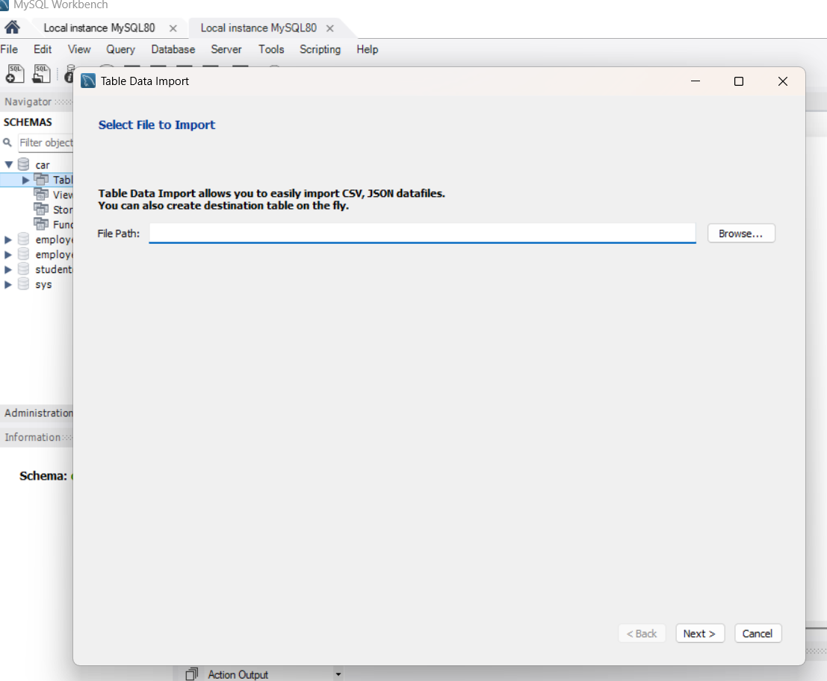

3. Choosing the Target Database
I selected the database CAR where the data should be imported.
I also created a new table (e.g., sales_excel) to hold the imported data.

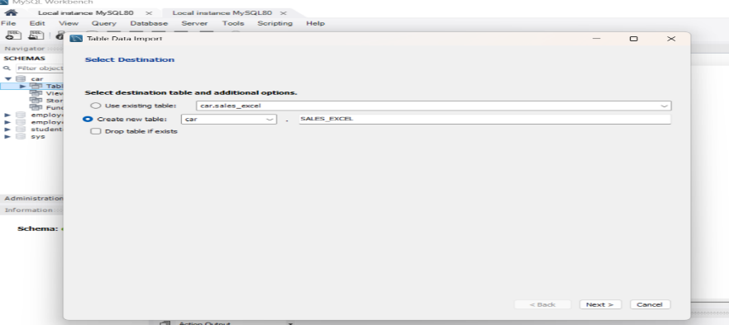
4. Mapping Columns
The wizard displayed a preview of the Excel data.
Here, I checked that:
- Columns were correctly mapped
- Data types were correctly recognized
- No values were missing
For example:
- Model → VARCHAR
- Colour → VARCHAR
- Selled_No → INT
- Sales_Range → VARCHAR

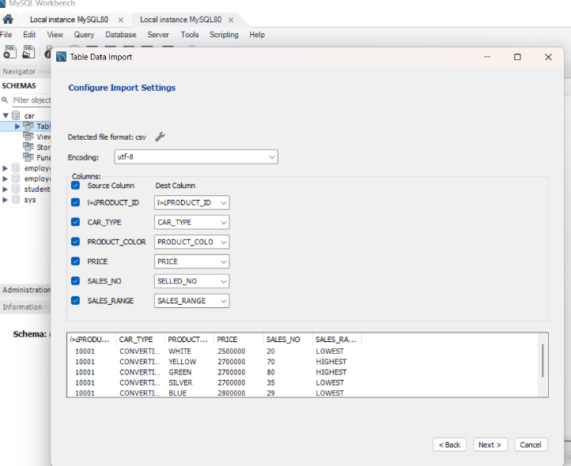

5. Importing the Data
Finally, I clicked Next and then Finish.
MySQL automatically created the table and inserted all rows from the Excel sheet.
A confirmation message appeared showing the number of rows successfully imported.

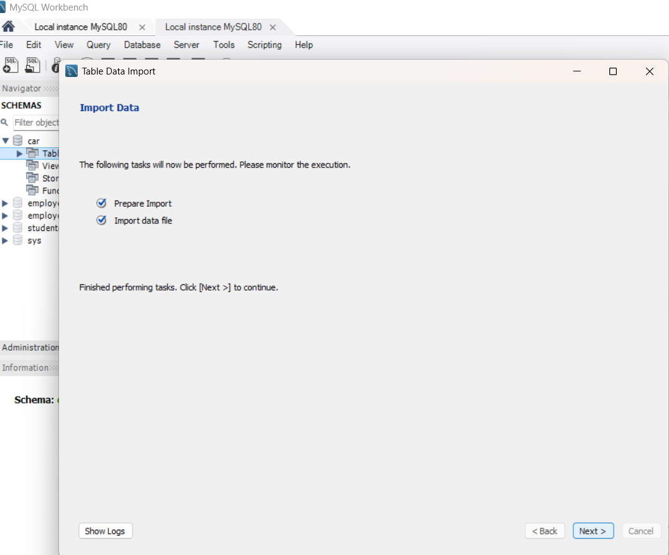

6. Verifying the Import
To ensure the data was loaded correctly, I ran:
SELECT * FROM CAR.sales_excel;
This displayed the complete table with:
- Correct rows
- Accurate formatting
- No missing or duplicated entries
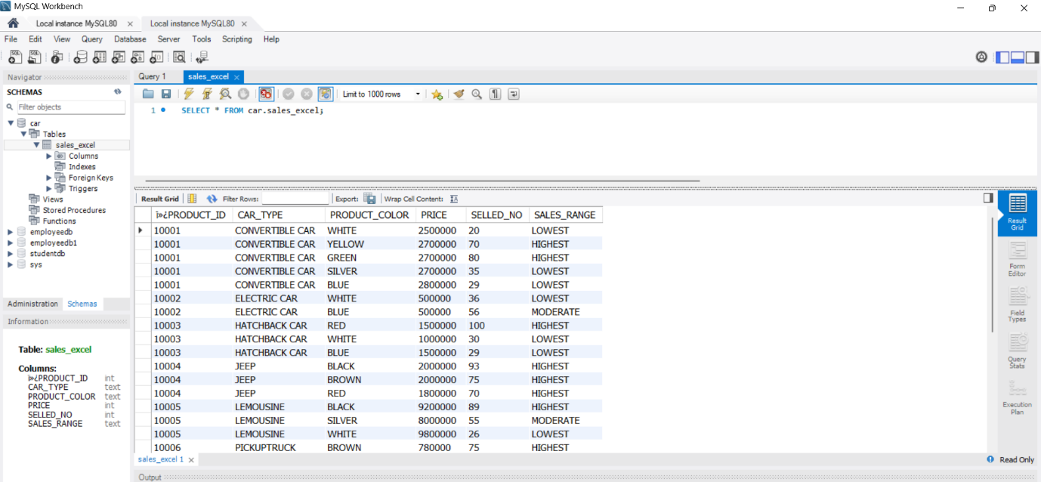

Step 7: Identifying the Highest Performing Car Colours Using MySQL
In this step, the goal was to filter and display only those car colours that belong to the HIGHEST sales category. This helps the company identify which colours have strong market demand and can be considered for the new car launch.
To achieve this, the following SQL query was executed:
2.3.2 SQL Query Used
SELECT DISTINCT PRODUCT_COLOUR, SALES_RANGE
FROM CAR.sales_excel
WHERE SALES_RANGE = 'HIGHEST';
Explanation of the Query
1. SELECT DISTINCT PRODUCT_COLOUR, SALES_RANGE
- PRODUCT_COLOUR displays the colour of the car.
- SALES_RANGE shows the performance category.
- DISTINCT ensures no duplicate colour names appear in the output.
2. FROM CAR.sales_excel
This specifies that the data is coming from the sales_excel table inside the CAR database.
3. WHERE SALES_RANGE = 'HIGHEST'
This filter ensures only rows with the HIGHEST category are shown.
All other sales ranges—MODERATE and LOWEST—are excluded.
Actual Output Interpretation
The query returned the following colours categorized under the HIGHEST sales range:
PRODUCT_COLOUR | SALES_RANGE
YELLOW | HIGHEST
GREEN | HIGHEST
RED | HIGHEST
BLACK | HIGHEST
BROWN | HIGHEST
SILVER | HIGHEST
RUBY RED | HIGHEST

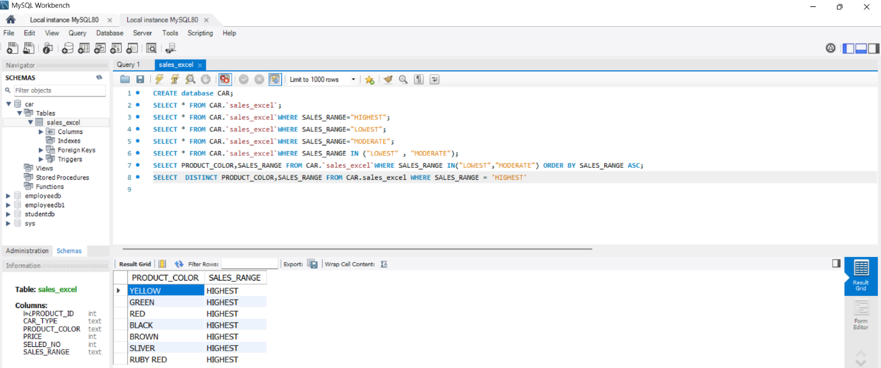

From the above output, the car manufacturer has selected six colours — red, black, green, yellow, blue, and silver — to create dual-shade car models. To finalize the best colour combinations, they collect a second opinion from customers who visit the showroom.
Opinion -2
Python in ETL Process – As second opinion
Python plays an important role in the ETL workflow because it can extract data from users, validate/clean the inputs, and finally load or store the data for further analysis.
In this project, Python is used to collect customer colour preferences for the new dual-shade car model.
1. Extract Phase (E – Extraction)
In this step, Python collects customer feedback directly from the command line using the input() function.
Syntax Used
liked_colour = input("Enter the car colour type: ")
Explanation
- This line reads the customer's selected car colour type (1 to 5).
- Each customer interacts with the system and their choice is taken as input.
- This data is not stored anywhere automatically, so Python becomes the “manual extraction tool.”
2.Transform Phase (T – Transformation)
Transformation involves cleaning, processing, or categorizing user inputs.
Your code transforms the raw data by:
Converting user choices (1, 2, 3, 4, 5)
Into Meaningful values (black/red, black/yellow, etc.)
Syntax Used
if liked_colour == "1":
print("You selected type1 which is black/red")
count_type1 += 1
Explanation
- Each if/elif block maps a number to a specific colour.
- The code ensures the customer's choice is counted correctly.
- Invalid inputs are handled using:
else:
print("you have entered invalid option")
Syntax Used
print("\nSummary of selections:")
print(f"type1:{count_type1}, type2:{count_type2}, ...")
Explanation
- The total count of each colour preference is shown.
- This becomes the final transformed data output.
- This data can then be loaded into MySQL or Power BI for visualization.
Python ETL Implementation
In this project, Python was used as an ETL (Extract–Transform–Load) tool to capture real-time customer feedback regarding preferred car colour combinations. During the Extraction phase, Python collected customer inputs using the input() function, allowing each visitor to select a preferred model type. The Transformation phase mapped the selected numeric options (1–5) to the corresponding colour combinations, validated the inputs, and incrementally counted customer preferences. Finally, in the Load phase, Python generated a summarized output displaying the total selections for each model type. This transformed dataset was later transferred to MySQL and visualized in Power BI to support decision-making for the new car colour launch.
Explanation of os Module in ETL Python Code
In this project, the Python os (Operating System) module is used to provide system-level interactions that improve the user experience during data collection. The primary purpose of using the os module is to clear the terminal screen after each customer’s input so that the next user gets a clean interface.
Why os Module Is Used?
The os module provides functions that allow Python to interact with the operating system.
In this ETL program, it is specifically used to clear the previous output from the console.
Syntax Used in the Program
import os
os.system('cls') # for Windows
What This Command Does?
os.system('cls')
- Executes the Windows command cls (clear screen)
- Removes all previous text from the terminal
- Provides a fresh screen for each new customer
- Makes the interface neat, readable, and more professional
Why Clearing the Screen Is Important in ETL?
Even though it's not part of data transformation, it helps during data extraction flow, because:
- It prevents confusion for customers
Each customer sees only the welcome message and table, not previous inputs.
- It makes data collection more organized
Inputs and outputs do not overlap.
- It simulates a real kiosk or showroom system Every user gets a clean session, just like a real digital survey too

Explanation of Modules and Emoji Codes Used
Component | Code Used |  | Purpose / Explanation |  | Why It Is Used in This Project
Pandas Module |  | import pandas as pd |  | Pandas is a data-handling library used to create and display DataFrames (tables). |  | To show the car models, colours, and prices in a neat, tabular format for customer reference.
OS Module |  | import os |  | Provides functions to interact with the operating system. |  | Used to clear the screen (os.system('cls') after each customer input to make the output clean and readable.
Car Emoji |  | car = "\U0001F697" |  | Unicode emoji representing a car 🚗 |  | Used to make the program look attractive and interactive when mentioning the car model.
Smiley Emoji |  | smile = "\U0001F60A" |  | Unicode emoji representing a smile 😊 |  | Used to make customer messages friendly and polite.
Welcome Emoji |  | welcome = "\U0001F44B" |  | Unicode emoji 👋 |  | Used in the welcome greeting to create a warm introduction.
Thank-You Emoji |  | thankyou = "\U0001F64F" |  | Unicode prayer/thank-you emoji 🙏 |  | Used to thank customers for giving feedback.
Unicode Emoji System |  | Example: "\U0001F697" |  | Unicode characters that generate emojis in terminal output. |  | Used instead of external modules like emoji so the script runs without installing extra packages.
The program uses pandas to display the colour options in a structured table, and os to clear the screen between each customer feedback entry. Emojis such as the car, smiley, welcome, and thank-you icons are added using Unicode escape codes, making the system more interactive and visually appealing without needing any external libraries.
Python plays a crucial role by:
- Adding human feedback to the ETL pipeline
- Supporting data-driven decision-making
- Helping the manufacturer choose the best colour combination
- Enhancing analysis with real-time opinion data
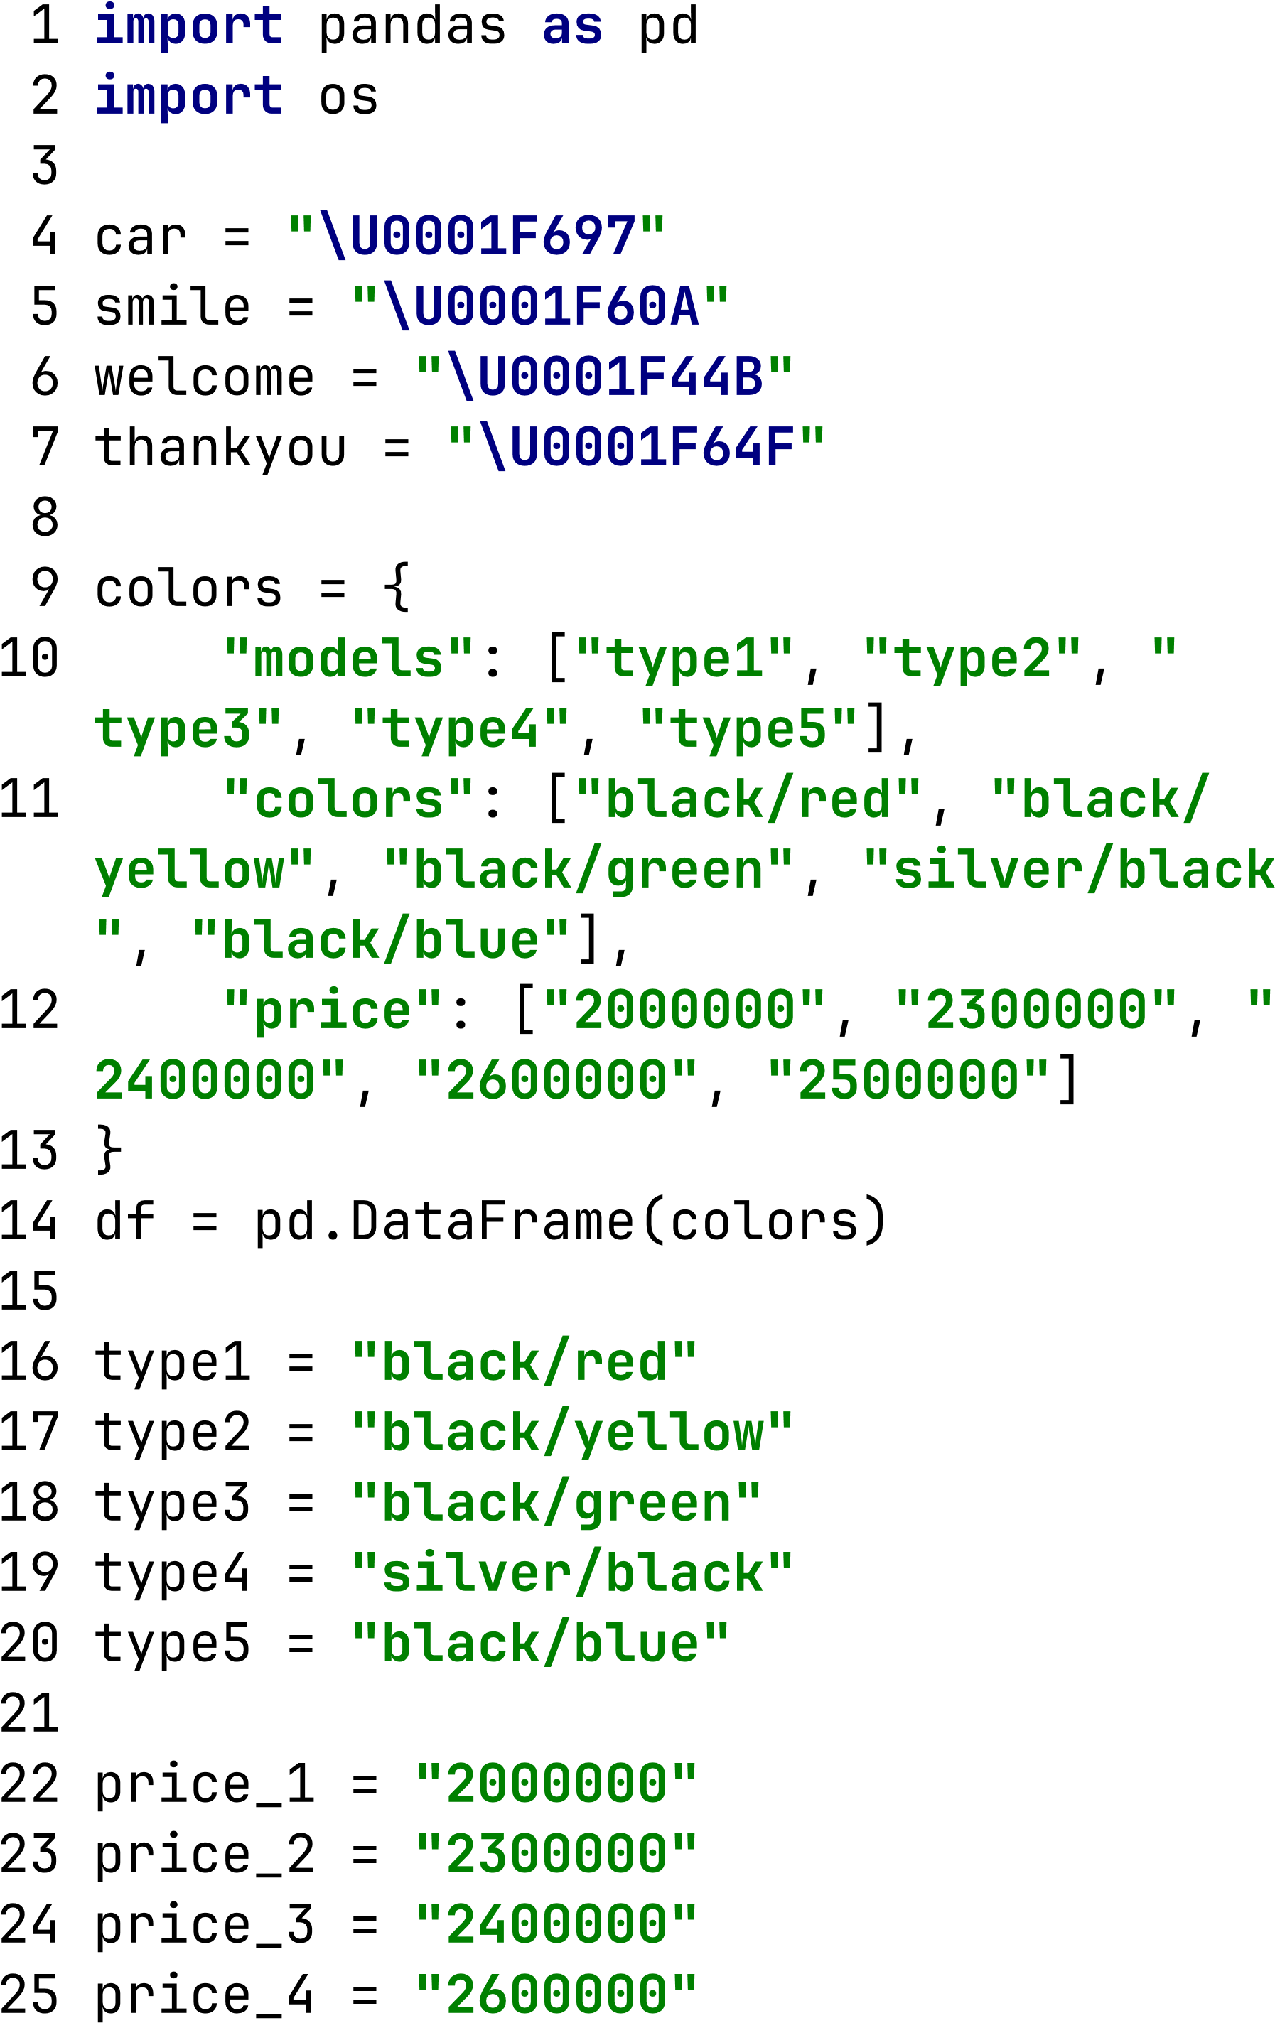
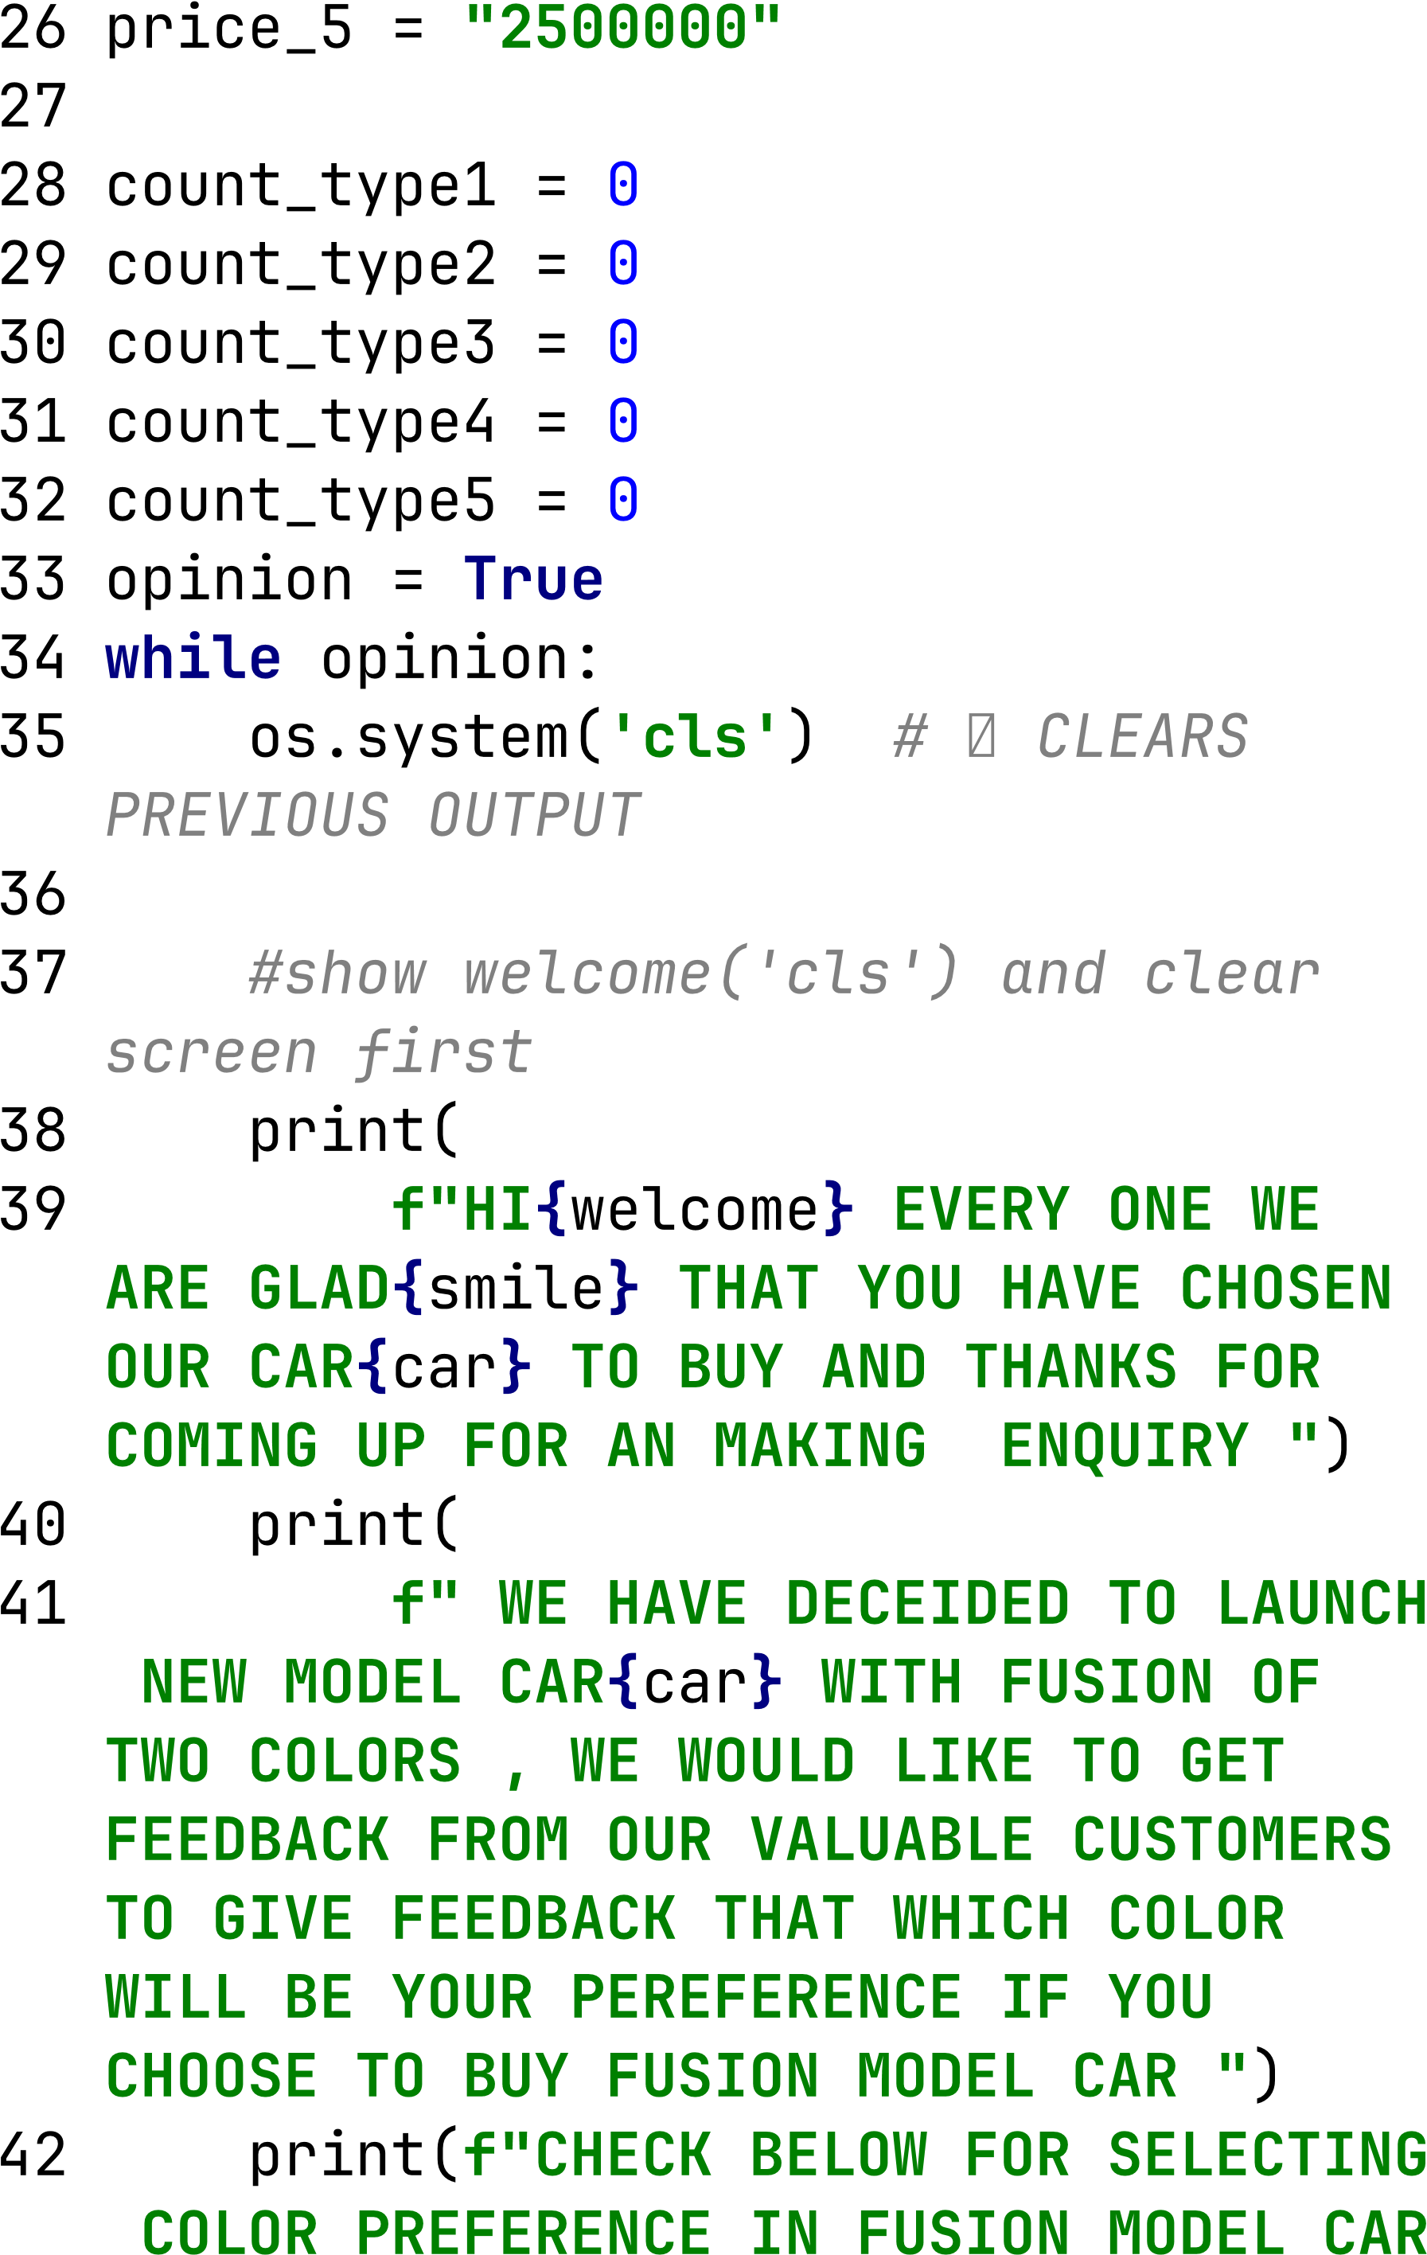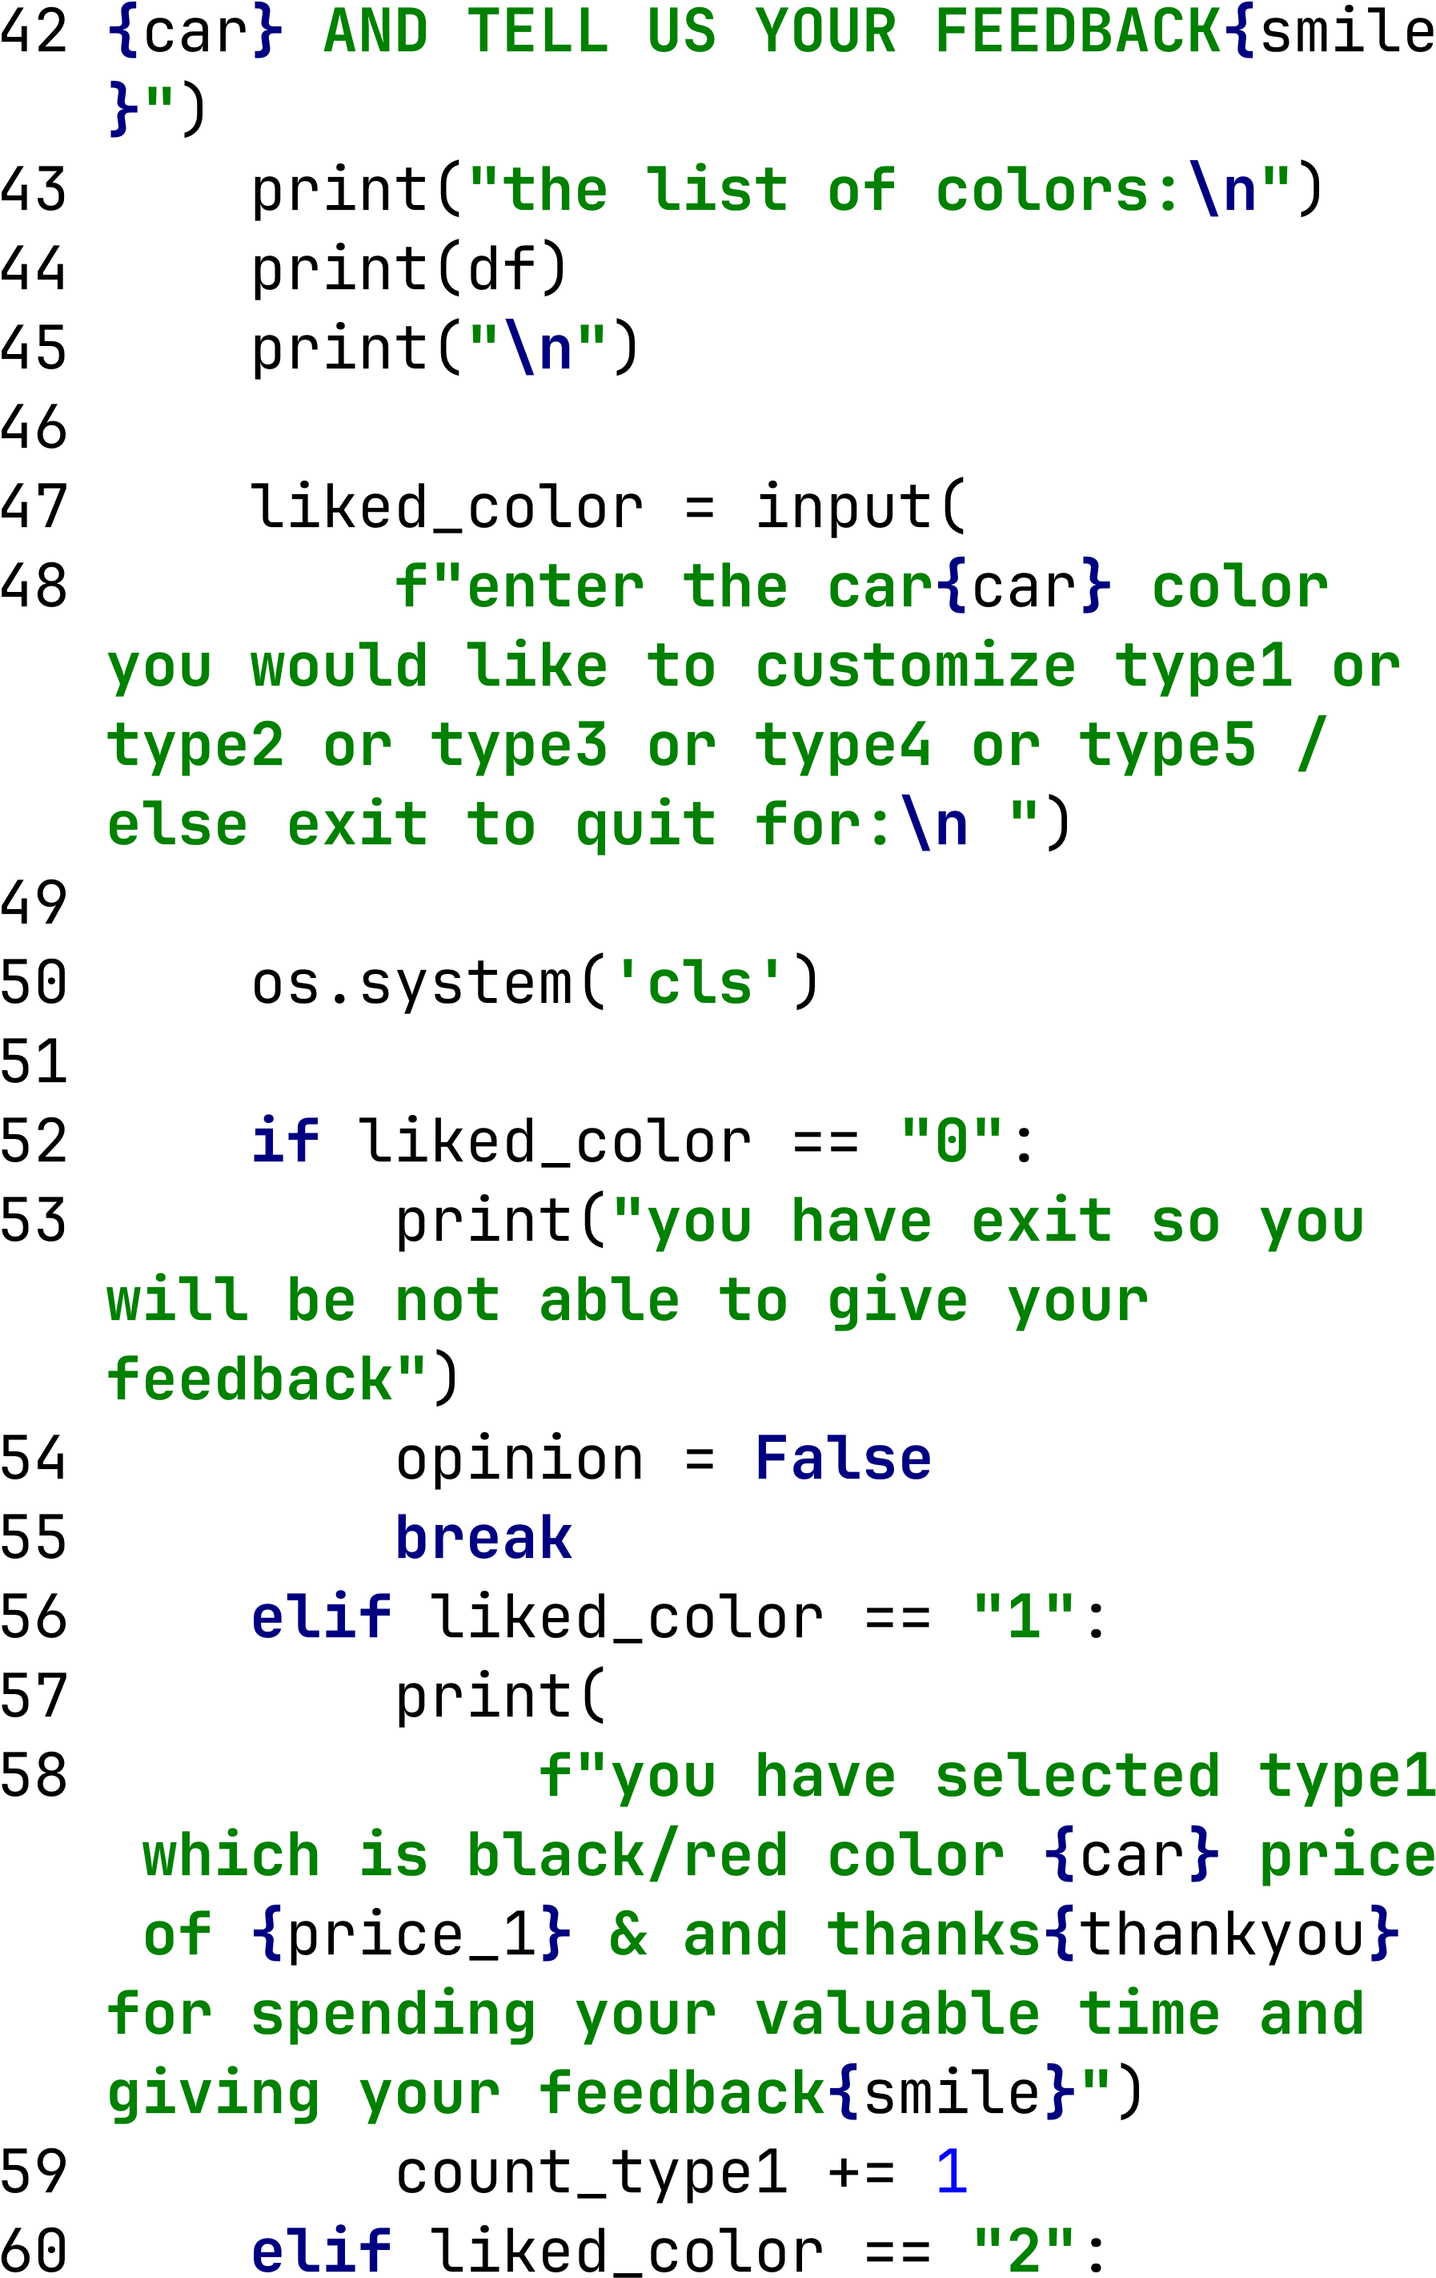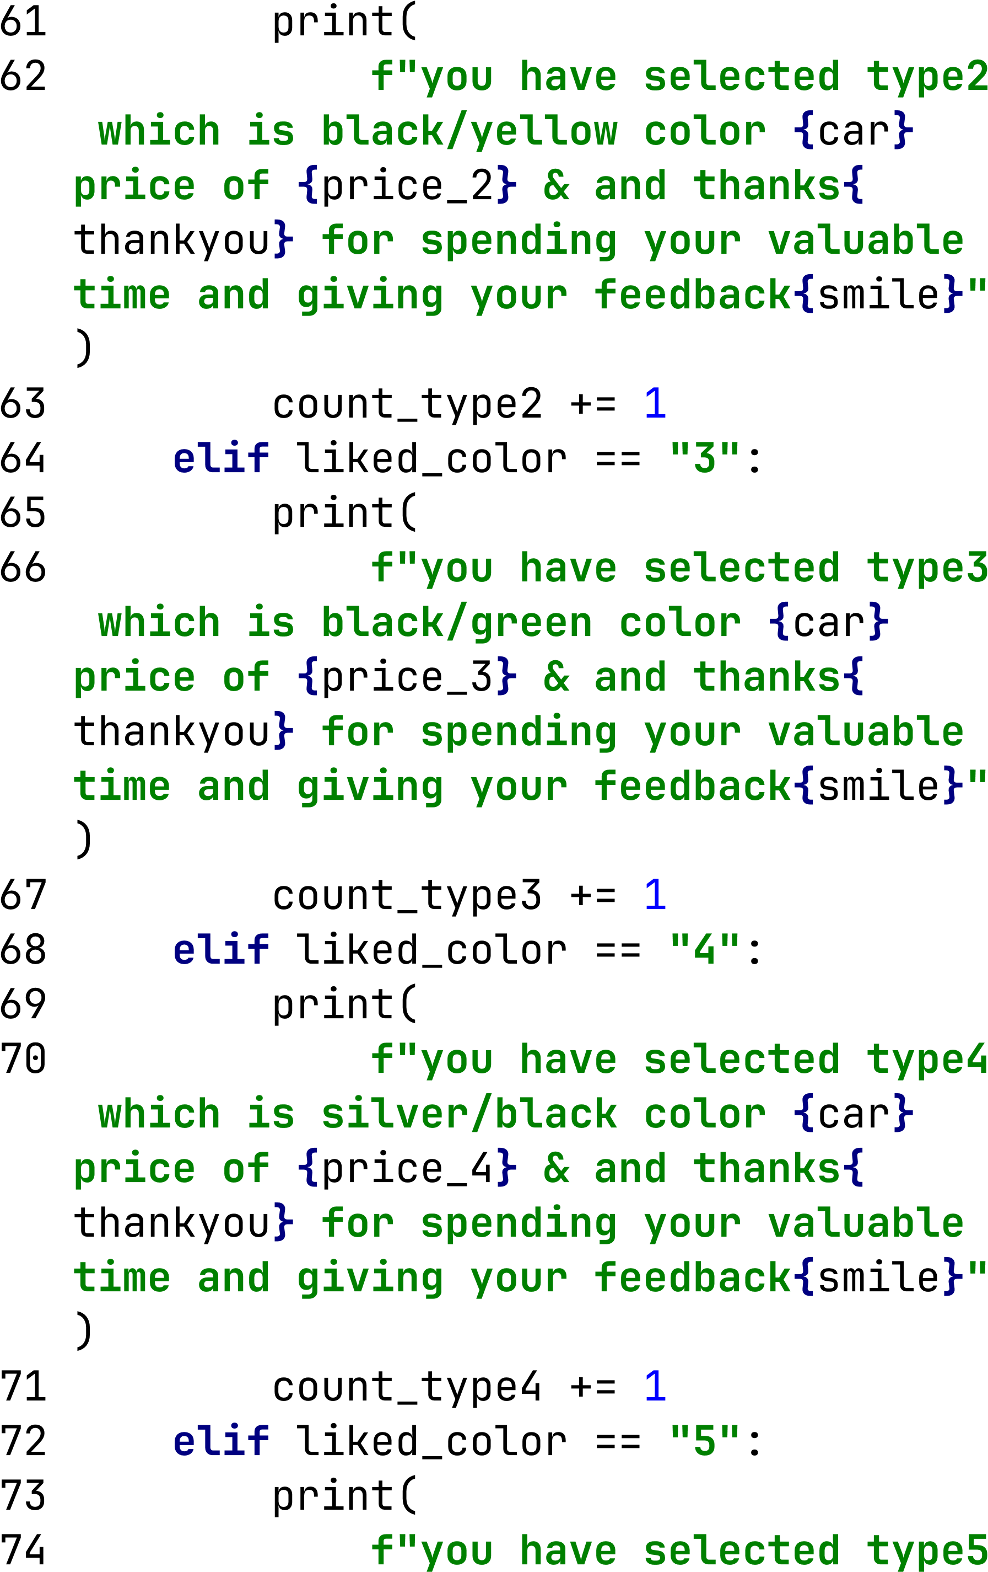

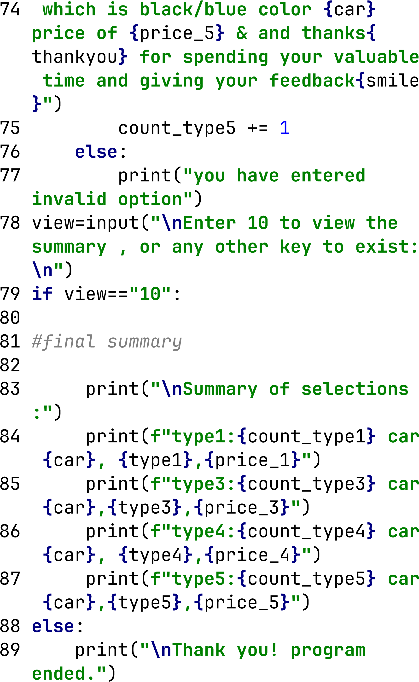
Output
The displayed output shows how the customer feedback collection system works for selecting the preferred dual–shade car colour for the new car launch.
1. Welcome Message
The program begins with a warm welcome message:
- Greets the customer
- Thanks them for visiting the showroom
- Explains that the company is launching a new fusion-colour car
- Requests customer feedback for selecting the best colour combination
This simulates how a real showroom executive would interact with customers.
2. Display of Available Car Colours (Extracted Data)
A table is displayed showing:
Model | Colours | Price
type1 | black/red | 2000000
type2 | black/yellow | 2300000
type3 | black/green | 2400000
type4 | silver/black | 2600000
type5 | black/blue | 2500000
This table is prepared from pandas DataFrame, which represents the five fusion colour options available for customer selection.
This acts as the reference menu for customers to choose their preferred colour.
3. User Input Section
The program asks:
“Enter the car 🚗 colour you would like to customize type1 or type2 or type3 or type4 or type5 / else exit to quit”
Here the customer can press:
- 1, 2, 3, 4, or 5 → to select a colour, OR
- 0 → to exit without giving feedback
In your case, the customer pressed 0, so the program shows:
“you have exit so you will be not able to give your feedback”
This means no additional feedback is collected.
4. Summary Trigger
After exiting, the program asks:
“Enter 10 to view the summary, or any other key to exit:”
This ensures customers can view all the previously collected feedback only if they choose to.
Your input: 10
So the program displays the summary.
5. Summary of Selections
This shows the total count of how many customers selected each colour:
type1: 52 car 🚗 black/red, 2000000
type2: 48 car 🚗 black/yellow, 2300000
type3: 23 car 🚗 black/green, 2400000
type4: 54 car 🚗 silver/black, 2600000
type5: 67 car 🚗 black/blue, 2500000
Interpretation
- type5 (black/blue) received the highest preference: 67 customers
- type4 (silver/black) received 54 customer votes
- type1 (black/red) received 52 votes
- type2 (black/yellow) received 48 votes
- type3 (black/green) received 15 votes
This summary provides final insight into which dual-shade colour is most preferred by customers.
6. Process Finished
Finally, Python shows:
“Process finished with exit code 0”
This means the program:
executed successfully
ended without errors
The Python program successfully collected customer feedback on preferred dual-shade car colours. Customers were able to choose a colour option or exit the system, after which they were given an option to view the feedback summary. The final summary shows the number of customers who selected each colour, helping the manufacturer decide the most preferred fusion colour for the new car launch

SCREENSHOT OF OUTPUT

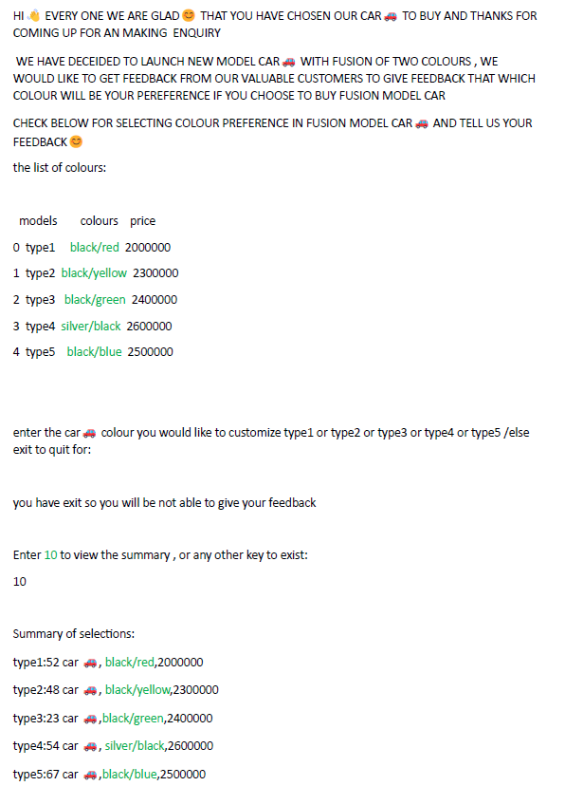

2.4 Load phase

In the Load phase, the final transformed data was imported into Power BI to generate visual reports. Power BI acts as the visualization layer in the ETL process, where the cleansed dataset is used to create interactive charts such as bar charts, pie charts, waterfall charts, and tables. These visuals help in identifying the highest-selling car colours, moderate sales ranges, and customer preference patterns. Screenshots of each step—from data loading to dashboard creation—are included below to demonstrate the complete loading and visualization process.

2.4.1 Step 1: Importing the Final Transformed Data
After completing the transformation in MySQL, the cleaned dataset is loaded into Power BI for visualization.
Power BI is used to create dashboards and charts that help in analyzing the car sales based on colours.
Step 2: Loading the Dataset
The dataset is imported into Power BI using:
- MySQL Connector, or
- Excel file, or
- Python script execution
This ensures the final processed data is ready for reporting.
Loading Opinion-1 Data into Power BI Using MySQL ODBC Connector
To load the transformed MySQL output into Power BI, the ODBC Connector was used. This allows Power BI to directly connect to MySQL Server and retrieve only the required data for visualization.
1. Open Power BI → Get Data
I started by selecting:
Home → Get Data → More → ODBC
The ODBC connector allows Power BI to establish a connection with external databases using DSN (
2. Connecting to MySQL Using ODBC
I selected:
MySQL ODBC Driver
Configured DSN with MySQL credentials
Entered server, username, and password
This step connects Power BI to the MySQL database where my ETL transformed data exists.

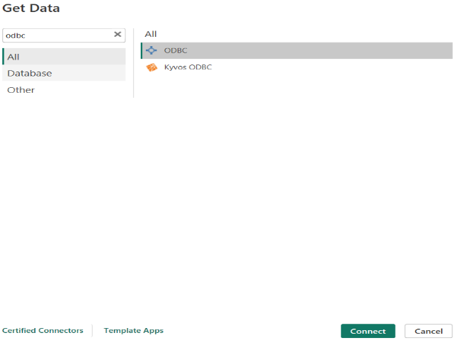
Screenshoot of connecting odbc
3. Use Advanced Options to Run SQL Query
In the ODBC connection window, I clicked:
Advanced Options → SQL Statement
Here, I entered the query:
SELECT DISTINCT PRODUCT_COLOR, PRICE, SELLED_NO, SALES_RANGE
FROM CAR.sales_excel
WHERE SALES_RANGE = 'HIGHEST';
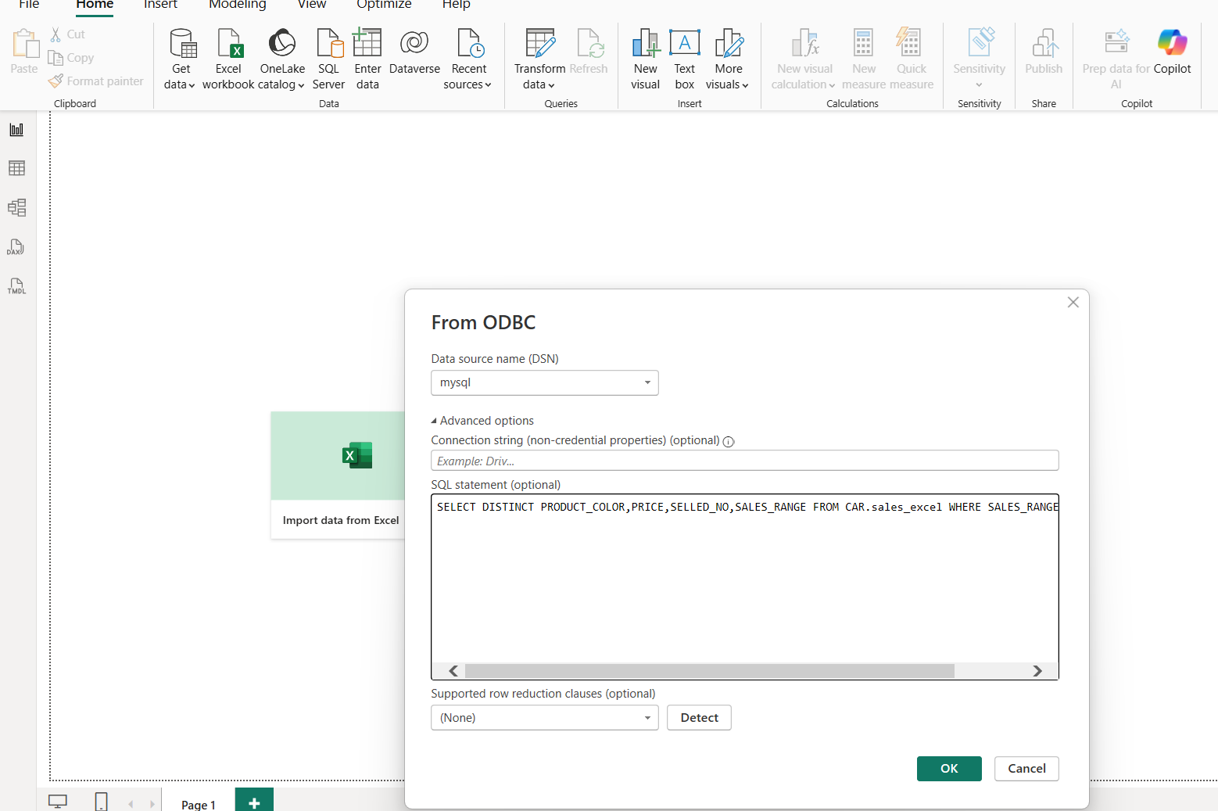

Screeenshoot of excecuting mysql query in odbc

4. Purpose of This Query
This SQL query extracts only:
- Unique Product Colors (Distinct)
- Price
- Number of Cars Sold (SELLED_NO)
- Sales Category (Sales Range)
And filters data to show only the HIGHEST sales range.
This helps Power BI load only the most important, clean, and filtered data for visualization.

5. Load Data to Power BI
After running the query:
✔ Power BI previewed the result
✔ I clicked Load
✔ The dataset was successfully added to the Power BI model
Now Power BI visuals can be built using:
- Bar chart for highest-selling colours
- Card visuals for “Total highest sales”
- Table view of filtered data
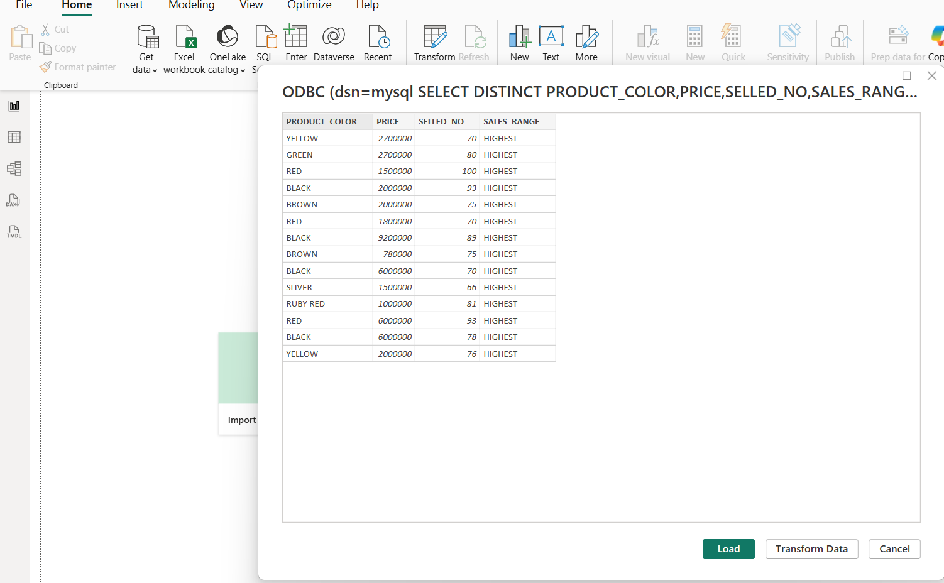
Screenshoot of loading data of odbc mysql query

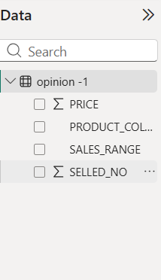
Screenshoot of after loading data

In the Load phase, Power BI was connected to MySQL using the ODBC connector.
An SQL query was executed in the Advanced Options of the ODBC connection window to fetch only the required fields. The system extracted distinct Product Colors, Price, Sold Numbers, and Sales Range where the Sales Range was categorized as 'HIGHEST'. This filtered dataset was then loaded into Power BI to generate visual reports for analyzing the highest-selling car colors. This approach ensures efficient data loading and improves report performance by avoiding unnecessary data import.

Step 3: Creating Visuals
After loading the data, different visuals such as bar charts, pie charts, tables, and cards are created.
These visuals help in understanding:
- Which car colour had the highest sales
- Which colour had lowest or moderate sales
- Customer preference distribution (from Python output)
- Price comparison based on colour

1. ETL – Opinion 2
In the Opinion-2 stage of the ETL process, customer preferences were collected based on the colour they would prefer if a dual-shade car model was launched. Instead of manually creating a table in MySQL, this dataset was created and loaded directly into Power BI using Python scripting.
Python provides flexibility in generating structured data, and Power BI supports direct execution of Python scripts, which makes integration faster and more efficient. This method allows dynamic data generation, eliminates database dependency, and reduces preprocessing time

2. Python Script Used for Creating the DataFrame
To prepare the Opinion-2 dataset, a Python dictionary was created containing four attributes:
- Car_Type – Represents the five available car models
- Votes – Number of customer preferences for each colour
- Colour – Colour combination preferred by customers
- Price – Price range of each model
The dictionary was then converted into a pandas DataFrame and assigned to a variable called dataset, which Power BI recognizes as a table.
2.4.2 Python code used inside Power BI
import pandas as pd

data = {
"Car_Type": ["type1", "type2", "type3", "type4", "type5"],
"Votes": [52, 48, 23, 54, 67],
"Colour": ["black/red", "black/yellow", "black/green", "silver/black", "black/blue"],
"Price": [2000000, 2300000, 2400000, 2600000, 2500000]
}

df = pd.DataFrame(data)
dataset = df

This DataFrame (dataset) is passed directly into Power BI for visualization.
Step-by-Step Explanation – Loading Python Data into Power BI
You can add screenshots of each step in your project.
Step 1:
Open Power BI → Home → Get Data → More
Step 2:
Choose Python Script as the data source.

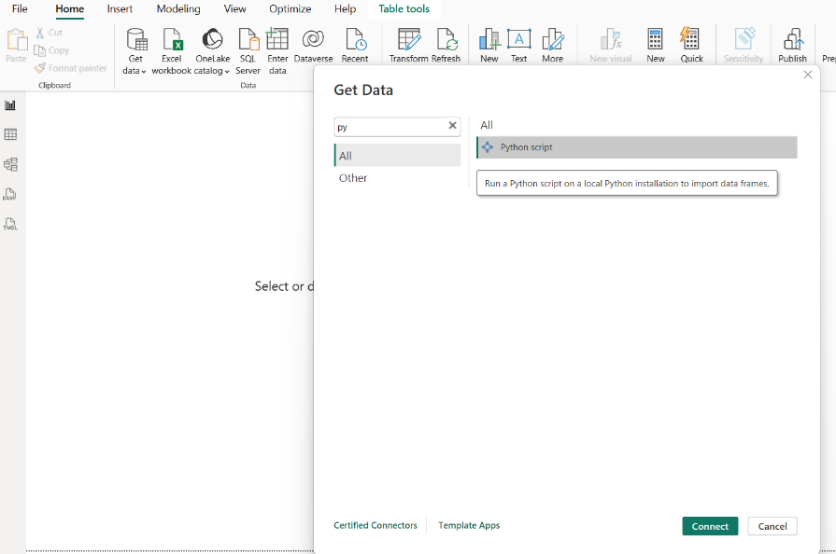
Screenshoot of selecting python script to load data

Step 3:
Paste the Python code into the script editor window.

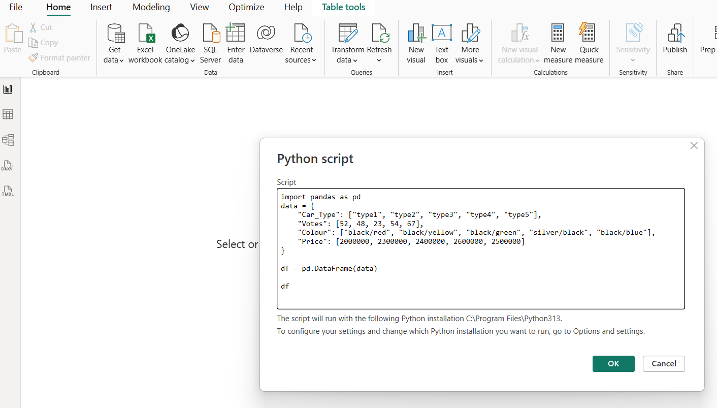
Screenshoot of pasting python script

Step 4:
Click OK.
Power BI will execute the Python script and show a preview of the DataFrame in the Navigator window.
Step 5:
Select the table named dataset and click Load.
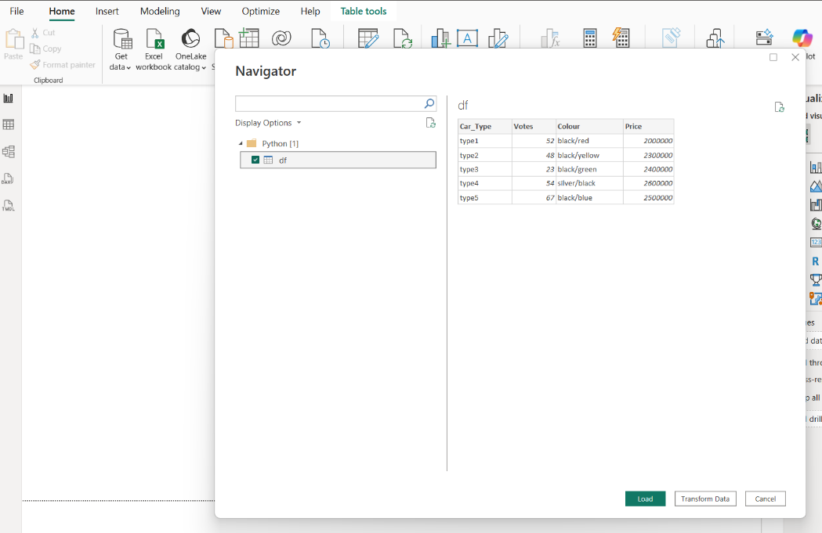
Screenshoot of loading python script data

Step 6:
The data is now available in the fields panel and ready to be used for charts and dashboards.

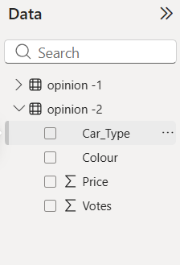
Screenshoot of loaded data in fields

4. Explanation of Output
After loading the data, the Opinion-2 output generated from Python was:
Car Type | Colour | Votes | Price
type1 | black/red | 52 | 2000000
type2 | black/yellow | 48 | 2300000
type3 | black/green | 23 | 2400000
type4 | silver/black | 54 | 2600000
type5 | black/blue | 67 | 2500000
Insights from the Output:
- Black/Blue (type5) received the highest customer votes (67)
- Silver/Black (type4) is the second most popular colour
- Black/Green (type3) received the lowest preference
- This customer feedback helps the company identify which dual-shade combination is best suited for launching the new model
- The final visualization in Power BI clearly highlights which colours are highly preferred
Step 4: Final Dashboard
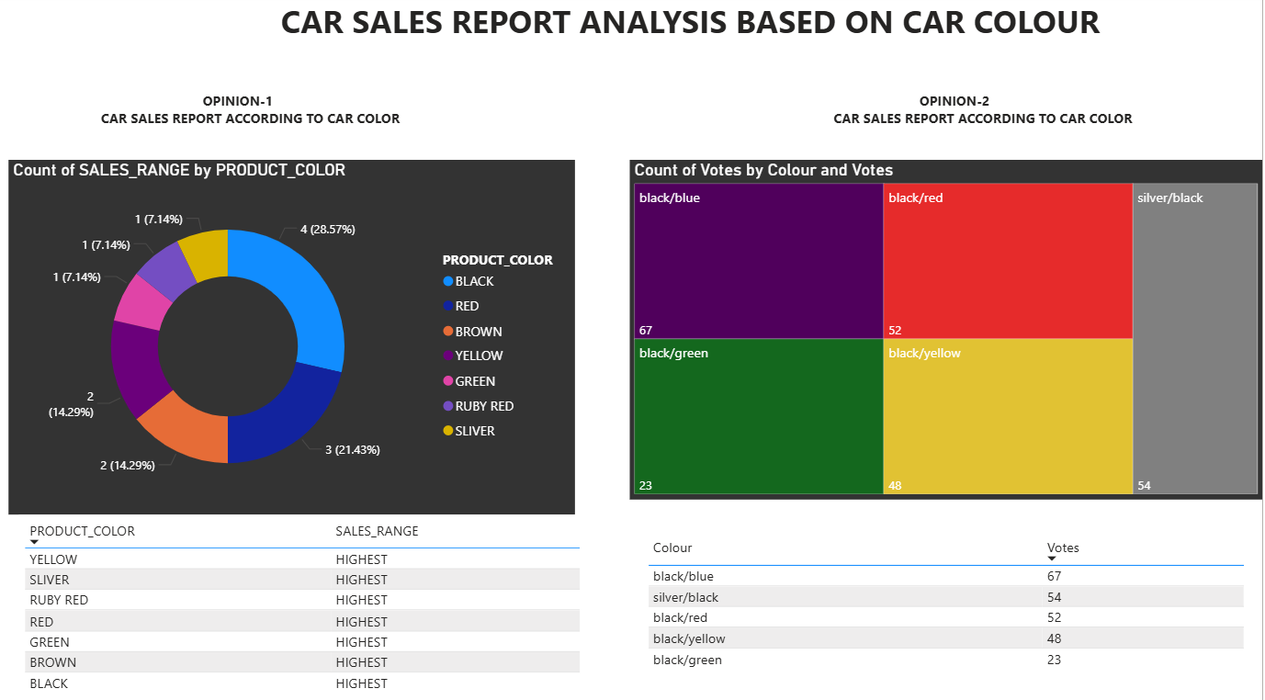
To provide a clearer and more meaningful comparison, both Opinion-1 (Past Sales-Based Colour Preference) and Opinion-2 (Customer Voting-Based Colour Preference) visualizations were combined on a single Power BI report page.
2.4.3 Displaying the two insights together helps in understanding the performance of each colour from two different perspectives:
1. Opinion 1 – Sales-Based Extracted Data (Historical Sales Pattern):This visualization represents the colours that performed well in the past based on actual sales numbers.
It helps to identify high-demand colours based on real market performance.

2. Opinion 2 – Customer Feedback Data (Future Buying Interest):This visualization is based on customer survey votes recorded through Python.
It shows current customer interest and preference trends for dual-colour cars.

Reason for Combining Both Visuals on the Same Page
To provide a clearer and more meaningful comparison, both Opinion-1 (Past Sales-Based Colour Preference) and Opinion-2 (Customer Voting-Based Colour Preference) visualizations were combined on a single Power BI report page.
Displaying the two insights together helps in understanding the performance of each colour from two different perspectives:

1. Opinion 1 – Sales-Based Extracted Data (Historical Sales Pattern)
This visualization represents the colours that performed well in the past based on actual sales numbers.It helps to identify high-demand colours based on real market performance.

2. Opinion 2 – Customer Feedback Data (Future Buying Interest)
This visualization is based on customer survey votes recorded through Python.
It shows current customer interest and preference trends for dual-colour cars.

Reason for Combining Both Visuals on the Same Page
- Makes comparison easy and visually clear
- Helps identify common colours that perform well in both past sales and current feedback
- Supports the company in making a data-driven decision about which colour combinations should be selected for the new dual-shade car
- Reduces confusion by presenting both datasets side-by-side
- Enables the viewer to observe trend continuity (past success + present preference)
- Gives a complete analytical view in one place instead of switching pages

Both Opinion-1 and Opinion-2 visualizations are displayed on a single report page for better interpretability.
Opinion-1 charts show the color performance extracted from historical sales data through Excel and MySQL, whereas Opinion-2 charts represent customer voting results generated using Python and loaded through Power BI’s Python script connector.
By viewing them together, the car manufacturer can easily compare past sales behaviour with current customer preferences, helping in selecting the most suitable colour combinations for launching the new dual-shade model.

Colour Selection Logic Between Opinion-1 and Opinion-2
In this project, Opinion-1 and Opinion-2 are interconnected. Opinion-1 uses historical sales data to find which single-colour cars were sold the most in the past. These high-performing colours indicate strong customer demand and market acceptance.
Instead of collecting new votes for all colours, only the top-selling colours from Opinion-1 were selected to create dual-shade combinations for the new car model. This ensures:
- Only successful, market-proven colours are used
- Fusion combinations are more likely to be accepted by customers
- The manufacturer reduces risk by selecting colours with strong historical performance
These selected colours were then used in Opinion-2, where customers visiting the showroom voted for their favourite dual-shade combination. The customer voting was collected using a Python script and loaded into Power BI.
By connecting Opinion-1 and Opinion-2, the final decision is based on real sales history + real customer feedback, making the analysis more reliable and business-oriented.
3. Final Conclusion
The ETL project successfully analyses car colour preferences using two perspectives: historical sales data and current customer choices. Opinion-1 identifies the highest-selling colours from past data using Excel, MySQL, and Power BI. Opinion-2 collects customer feedback using a Python-based voting system. The dual-shade colour options used in Opinion-2 were intelligently selected from the highest-performing colours found in Opinion-1, ensuring stronger market relevance.
Both datasets were finally loaded into Power BI and visualized on the same page, allowing easy comparison between historical demand and current customer interest. This combined insight helps the car manufacturer make a data-driven decision on which dual-colour models should be launched in the market. The project demonstrates a complete ETL workflow with practical business application.

2.5.1 INSIGHTS FROM THE ETL PROJECT
Based on the combined analysis of Opinion-1 (historical sales) and Opinion-2 (customer voting), the following key insights were identified:
1. Colour Performance Matches Customer Interest
The colours that performed well in historical sales (Opinion-1) also received high votes in customer feedback (Opinion-2).
This indicates that customer preferences have remained consistent over time.
2. Black/Blue and Silver/Black Are the Top Contenders
Both colours showed:
- High sales in past performance
- Strong customer preference in the Python voting results
This makes them ideal candidates for the new dual-shade model.
3. Market Demand Supports Dual-Shade Launch
Since the selected colours were already popular individually, combining them into fusion shades increases the chances of attracting customers.
4. Lowest-Performing Colours Received Least Votes
Colours like black/green received both low sales numbers and fewer customer votes, indicating low market demand.
These colours are not recommended for the new model.
5. Single-Page Power BI Visualization Improved Clarity
Displaying Opinion-1 and Opinion-2 results on the same Power BI page helped in:
- Easy comparison
- Faster decision-making
- Clear understanding of trends
6. Combining ETL Tools Improved Accuracy
Using multiple tools (Excel, MySQL, Python, Power BI) ensured that:
- Data was cleaned and validated
- Views were compared from multiple angles
- Insights were reliable and business-oriented

The combined visualization clearly shows that Black/Blue and Silver/Black are the most preferred colours based on both past performance and customer voting, supporting their selection for the new dual-shade launch.

RECOMMENDATIONS
Based on the findings, the following recommendations are suggested:
- The manufacturer should launch the new dual-shade model using Black/Blue and Silver/Black, as both show high customer acceptance.
- Avoid colours that have consistently low performance such as Black/Green.
- Continue collecting customer feedback regularly to track changes in preference and update trends.
- Use the same ETL pipeline for future datasets to maintain consistency in data analysis.
- Combine customer feedback with additional factors like pricing, design, and model type for future decision-making.

LIMITATIONS (Optional but very professional)
- Customer feedback for Opinion-2 was collected only from showroom visitors, not the full target market.
- The analysis focused only on colour preference; other purchase factors were not considered.
- Excel sales data accuracy depends on the correctness of the recorded dataset.
- The sample size for Opinion-2 was limited and may not represent all customer demographics.

FUTURE SCOPE
This project can be expanded in several ways:
- Automating the ETL pipeline using scheduled Python scripts or Apache Airflow.
- Adding real-time data collection using online forms or APIs integrated with Power BI.
- Building predictive models (machine learning) to forecast future colour trends.
- Including additional variables such as region-wise sales, customer age group, seasonal trends, model popularity, etc.
- Creating a dashboard for management to track colour performance monthly or annually.

CONCLUSION

The ETL project successfully integrates multiple tools—Excel, MySQL, Python, and Power BI—to analyse car colour preferences from both historical data and customer feedback.
Opinion-1 helped identify the highest-selling colours using past sales records, while Opinion-2 collected real-time customer preferences using a Python-based survey system.
Only the highest-performing colours from Opinion-1 were selected for Opinion-2, ensuring that customer feedback was gathered only on colours with proven market success.
By visualizing both opinions together in Power BI, the manufacturer can easily compare past demand with current interest and make a clear data-driven decision on launching a dual-shade car model.
Overall, this project demonstrates a complete ETL workflow and provides valuable insights that support strategic product design and marketing decisions.

